QIBA-DRO-Evaluation tool

Manual, Version 1.0

Tianbao Zhang, Longquan Chen and Hendrik Laue

Table of Contents

Introduction 2

Starting the tool 3

Getting ready before evaluation 4

Importing the reference data (optional) 4

Importing the calculated data 5

Editing the image dimensions (optional) 6

Evaluating the data 6

Evaluation results analysis 6

Comparing the calculated maps 6

Overviewing the data relation 8

Viewing the data distribution 9

Statistics tables 12

Covariance and correlation 13

Concordance correlation coefficients 14

Model fitting 15

T-test results 16

U-test results 17

ANOVA results 18

Chi-squared test results 18

Export the results as PDF 19

Appendix I 21

How to download the source code 21

How to run the source code 21

How to execute the application for batch processing 22

# Introduction

Accurate and reliable algorithms are an important basis for quantitative imaging. Especially in dynamic contrast-enhanced magnetic resonance imaging (DCE-MRI) a large number of implementations of compartment models are available. These different implementations frequently lead to variations of derived parameters even for identical data sets. Consequently, setting global thresholds or comparing results in multi-center studies is impossible without setting a standard for the algorithms. One way to validate these data is a digital reference object (DRO) consisting of numerically created medical image data sets with a defined matrix of parameters. Some of those have been developed at Duke University, USA [[QIBA data](https://dblab.duhs.duke.edu/modules/QIBAcontent/index.php?id=1)] and can be downloaded to evaluate software and algorithms.

The QIBA-DRO-Evaluation tool was designed to facilitate the comparison of results from algorithm with the theoretical parameters. This allows the user to validate own software or the software developed by third party providers or vendors. It offers difference maps, correlations analysis, linear models and many more tools to evaluate the results of software. It can also guide the developer to the cause of the differences by identifying relations to the theoretical values. It is open source and can be freely distributed.

Please feel free to report bugs or comment on this tool or ask for enhancements.

# Starting the tool

The QIBA-DRO-Evaluation tool is provided as a self-extracting software package for Windows, Linux and Mac OS. Simply download and install the software by running the Installer. Appendix I describes how to download and run the source-code version. In the installer versions, the application is started by simply clicking or double clicking the application button.

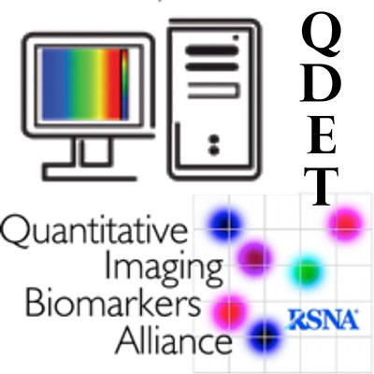

Figure 1: Welcome splash screen

Once started, you will be asked to select the analysis mode of the tool. This can either be Ktrans-Ve analysis mode, or T1 analysis mode. The first mode allows comparing results from the general kinetic model (GKM) and the latter from the flip angle mapping DRO, both provided by [Duke University](https://dblab.duhs.duke.edu/modules/QIBAcontent/index.php?id=1).

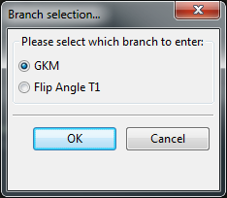

Figure 2: Analysis mode selection dialog

# Getting ready before evaluation

## Importing the reference data (optional)

The reference data for the DROs provided by Duke is part of the installer and is loaded when starting the applications (see Figure 3). The reference data is included in the folder “reference_data”, under the installation directory.

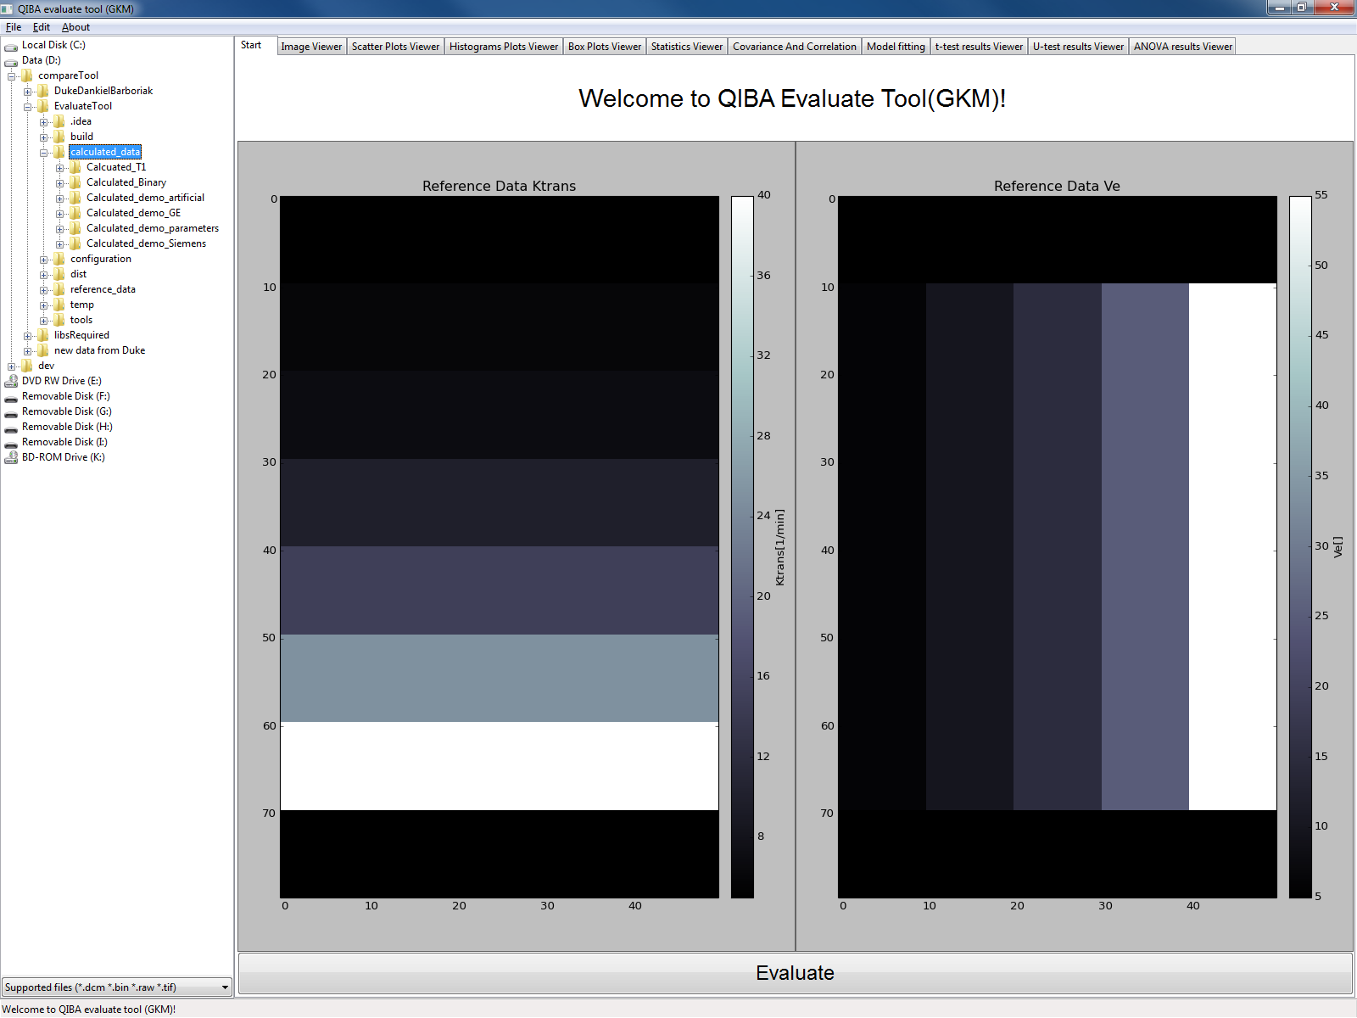

Figure 3: Start page

You can load other reference data from the application menu. You can find the menu entries “Edit-> load reference Ktrans…” or “Edit-> load reference Ve…” for the parameters to be evaluated. By selecting one of these menu entries, a file selection dialog will pop out, in which you can choose the file to be used as reference data (See Figure 5 and Figure 6).

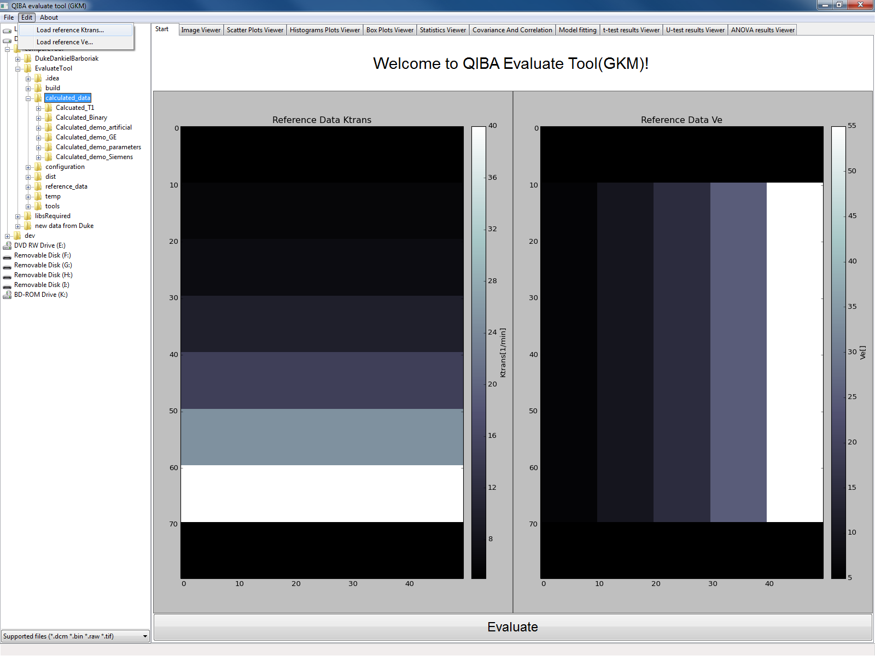

Figure 4: Load reference file option

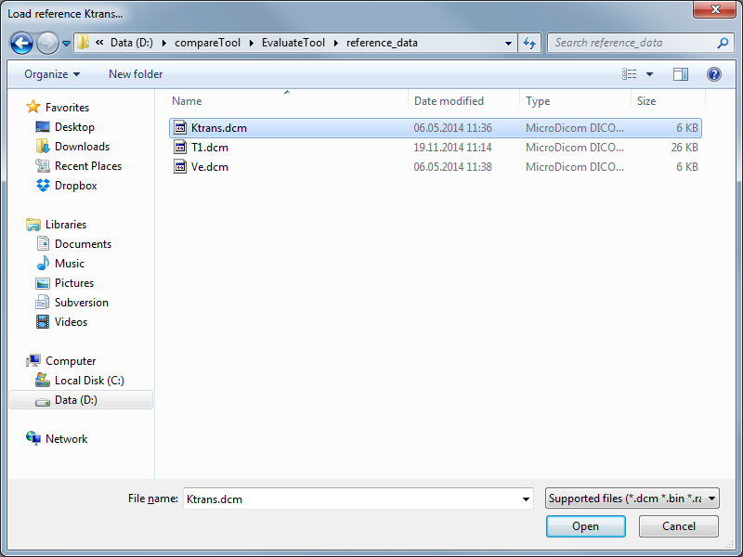

Figure 5: Reference file selection dialog

## Importing the calculated data

On the left side of the graphical user interface (GUI), you can find the current folder tree of your computer. On the folder level, the supported file types are displayed. Select the file by left clicking on it, and then right click on the same file in order import from the pop-out menu. In ‘GKM’-mode, you can import the selected file as either calculated Ktrans data or calculated Ve data. In ‘Flip Angle T1’-mode, you can select the calculated T1 map.

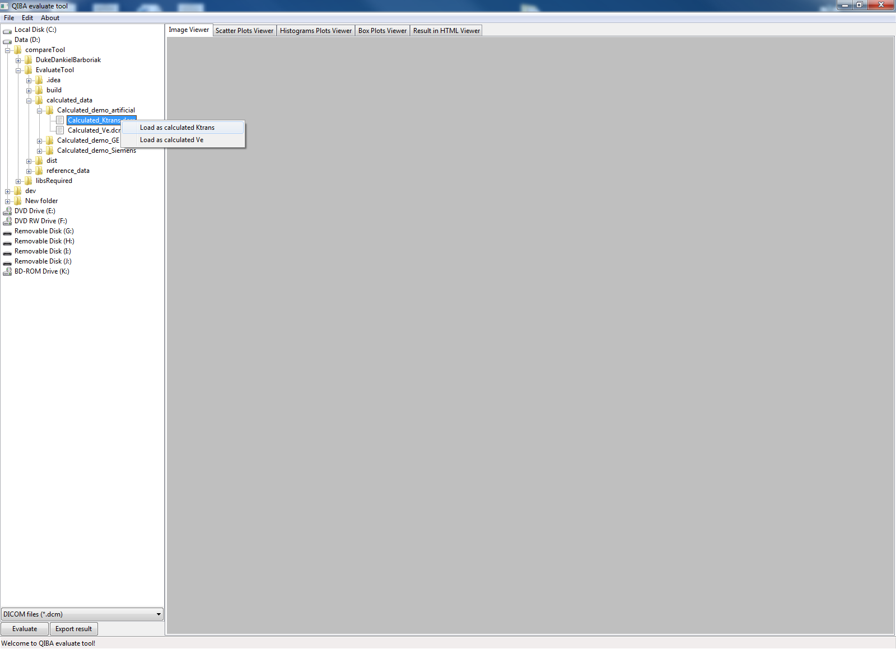

Figure 6: Load calculated file

## Editing the image dimensions (optional)

The dimension of the image will be automatically determined by the size of the default reference file. When new reference file(s) is imported, the image dimensions will be updated automatically, except for the binary reference file (e.g. *bin, *.raw file). In the case of binary reference file, a dialog will pop out and ask you to input the image dimensions (see Figure 8).

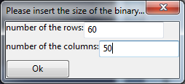

Figure 7: Image dimension input dialog

## Evaluating the data

When the calculated data and reference data is properly imported, the application is ready to execute the evaluation. The data is compared by pressing the evaluate button at the bottom of the application window. After pressing this button, the evaluation process will take place (this may take a few seconds), and then the results of the evaluation will be shown in a series of tabs consequently.



Figure 8: Evaluation button

# Evaluation results analysis

## Comparing the calculated maps

The tab “Image Viewer” shows the preview of the calculate data maps, the error compared to the reference files, and the normalized error, in each column from the left side to the right side. There are color bars besides the figures, which you can refer to read the value range and value mapping. The figures arrangement is different between the “GKM”-mode and the “Flip Angle T1”-mode, as they have different number of figures to show. The description bellow will be for “GKM”-mode, which is analogous to that of “Flip Angle T1”-mode, except for that the row of figures is transposed to a column.

The first column shows the calculated Ktrans and Ve maps in black and white. You can have a general impression of the value varying according to the changing of the parameters. Generally the brighter the pixel is, the higher the calculated value is.

The Second column shows the error map between calculated and reference data. Each pixel is the subtraction result between the corresponding pixels in calculated and the reference data. Generally the more the color approaches to the red direction, the larger the error is.

The third column shows the normalized error. This is out of the consideration that the error could be related with the original value itself. Therefore normalized error may give a more uniformed standard of the error level. Each pixel’s value comes from the division of the error by the reference pixel value. Similarly as the error map, the more the color approaches to the red direction, the larger the normalized error is.

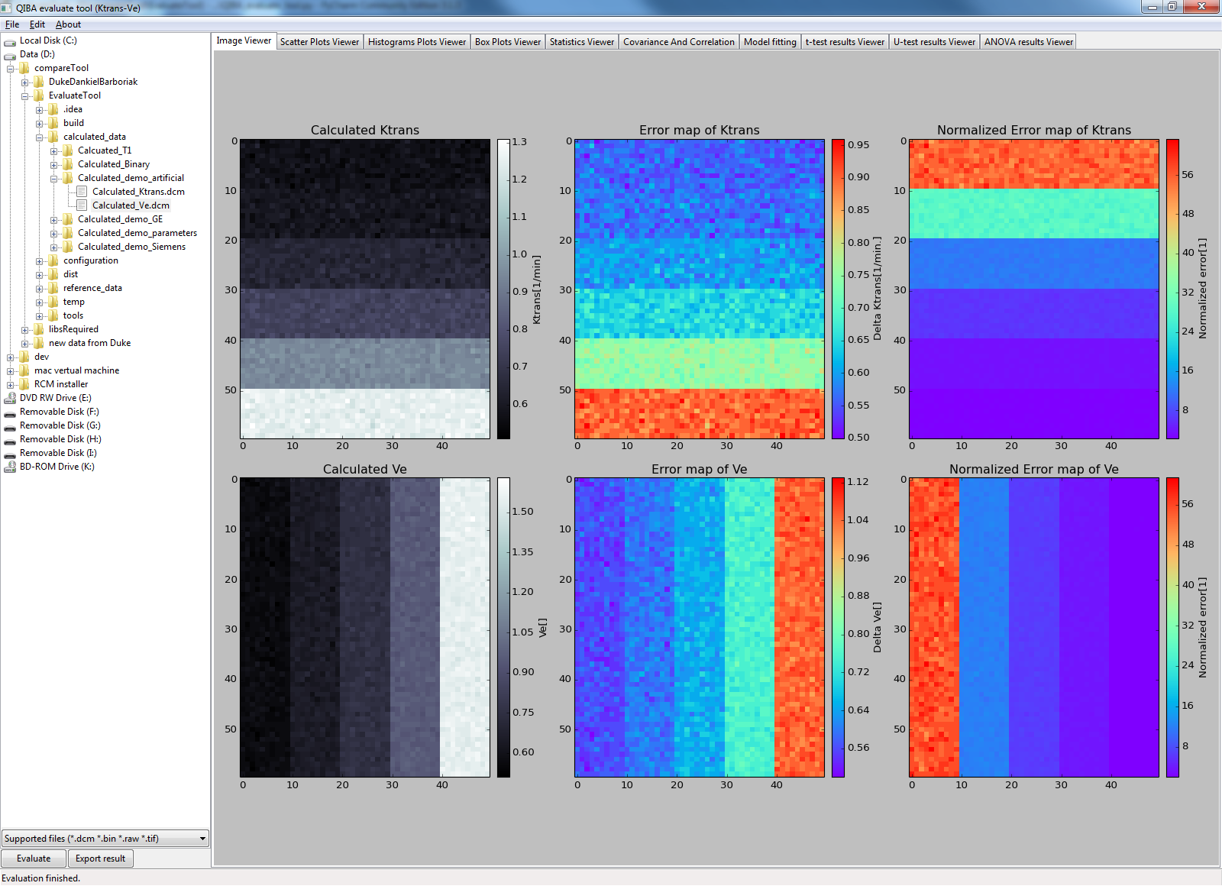

Figure 9: Image viewer for "GKM"-mode

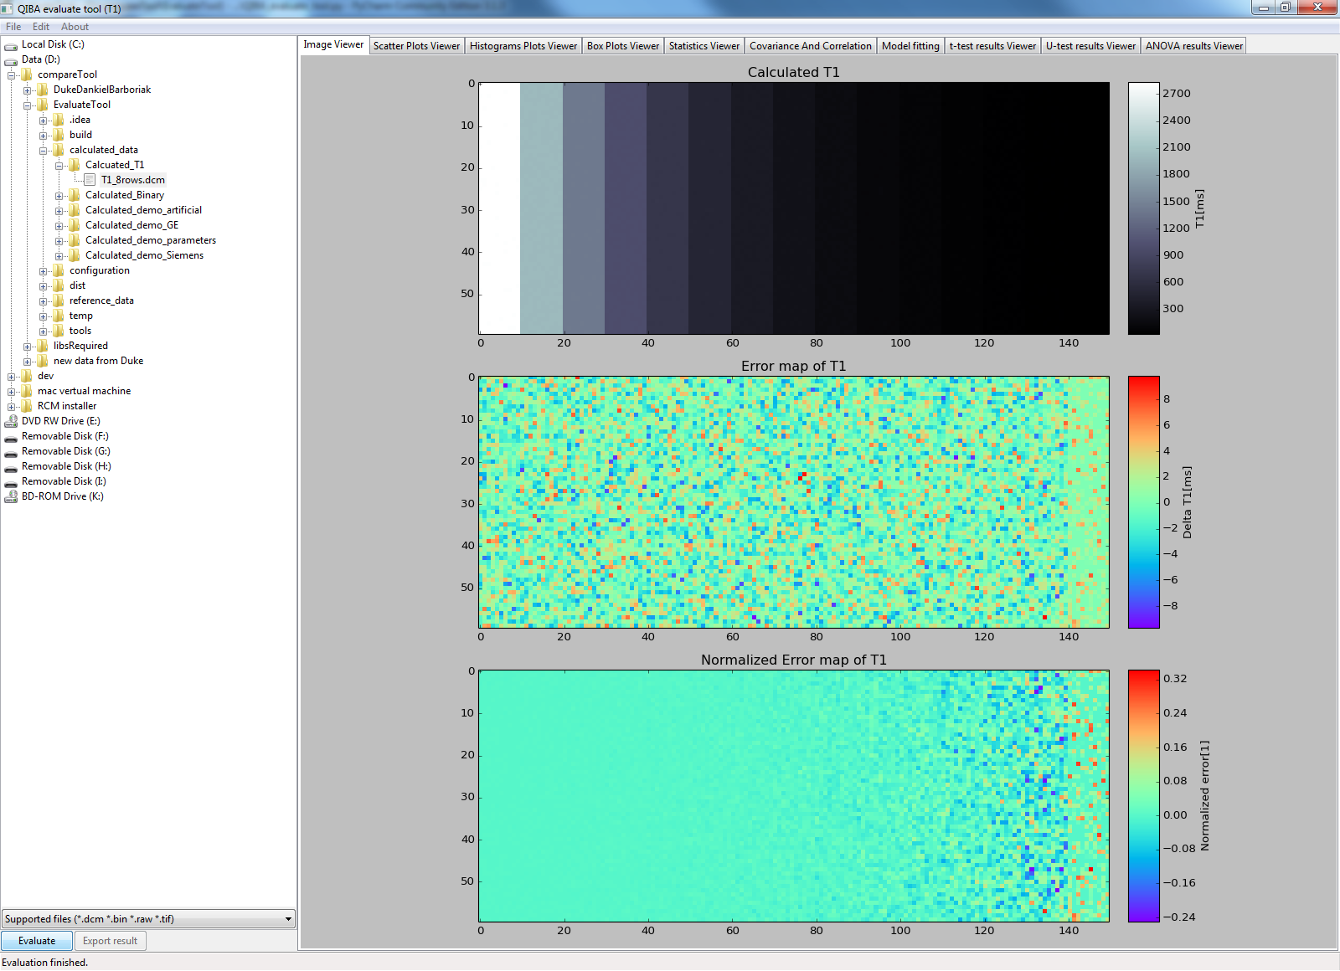

Figure 10: Image viewer for "Flip Angle T1"-mode

## Overviewing the data relation

The tab “Scatter Plots Viewer” shows the scatter plots of the calculated and corresponding reference maps in a same figure. As described in the legend, the blue and green dots denote pixels from the calculated and reference respectively. The description under will be for “GKM”- mode, whilst the condition for “Flip Angle T1”-mode is analogous.

Considering the reference Ktrans (or Ve) has discrete values, being a constant for each row (or column) in the data map, the pixels of corresponding row (or column) will be plotted to align with the x-axis.

For the reference data, the pixels in one row (for Ktrans) or column (for Ve) share the same constant value. Therefore in the scatter plot it shows that all green dots of a row (or column) overlap to each other. For the calculated data, as they share the same parameter, the blue dots align to the same x-axis. But they may scatter vertically, showing there’s variance of the values in a row (or column).

From these plots you can see the trend of the values, which offer some information of which model (e.g. linear or logarithmic) the calculated parameter may fit. For example, with the artificial calculated data which were generated from the reference data by adding Gaussian noise, scaling by two and adding 0.5, it can be easily read from the plots that the calculated data follow the linear model, and have a scaling factor and an extra constant bias.

The button ‘Switch viewing’ at the bottom of the viewer offers the possibility to view the data at different scale. In case the calculated data has a large range of values, the slope of the data may become less obvious, while the users can have a clear view of the data variance in each patch. In order to have a better view of the calculated data and the reference data in terms of slope, switching the viewing scale may be a plausible option.

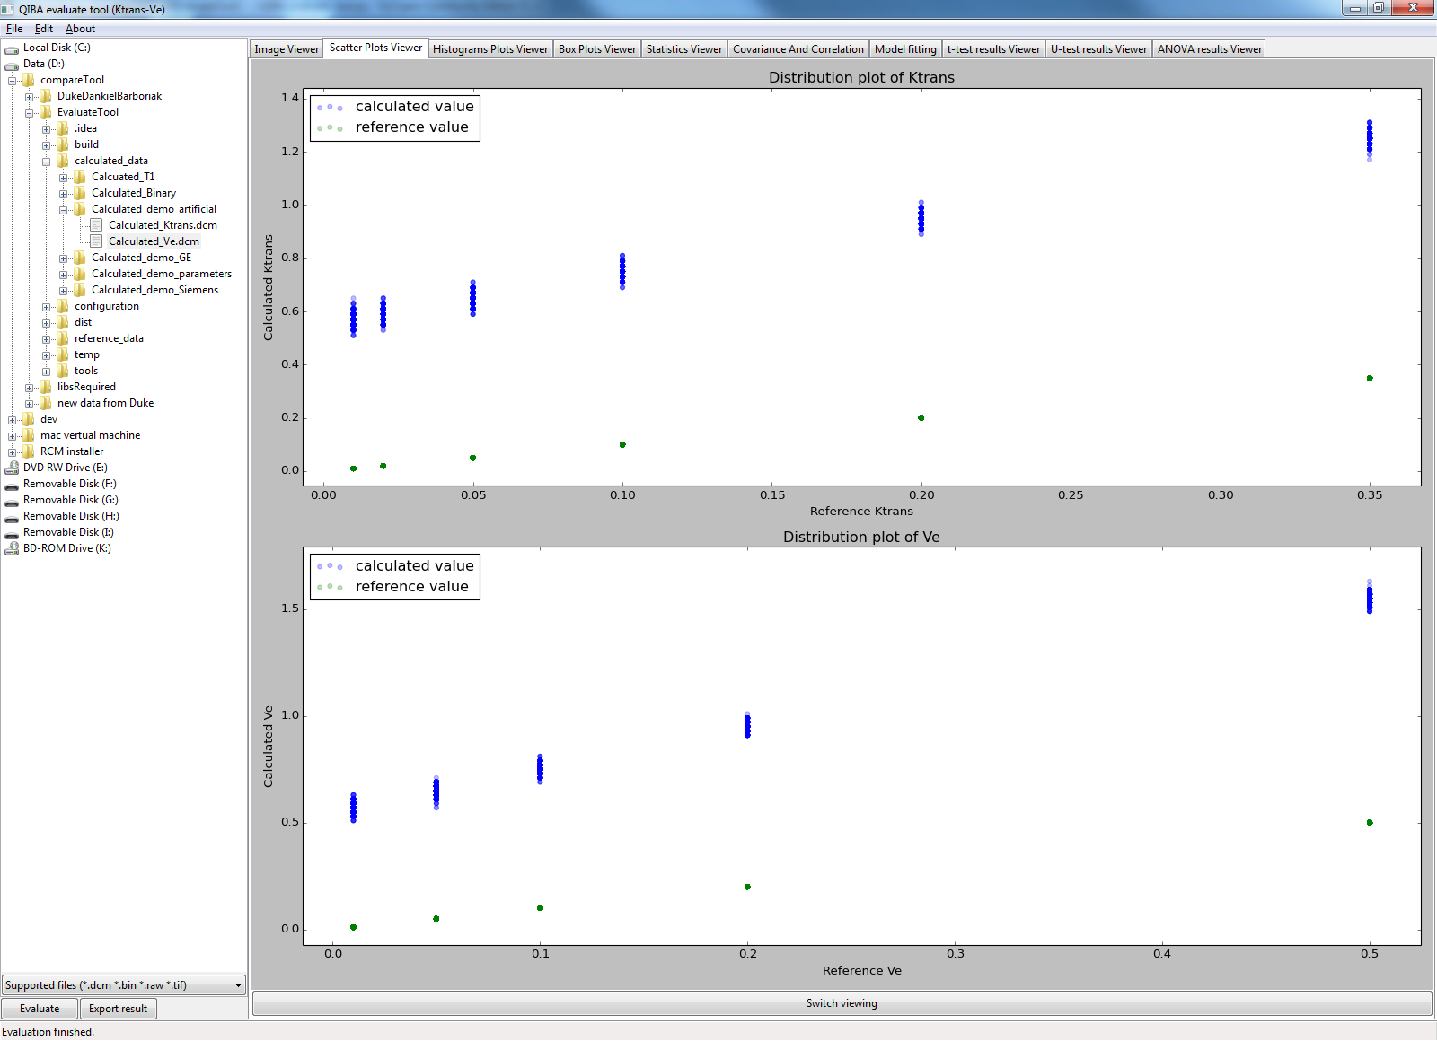

Figure 11: Scatter plots for "GKM"-mode

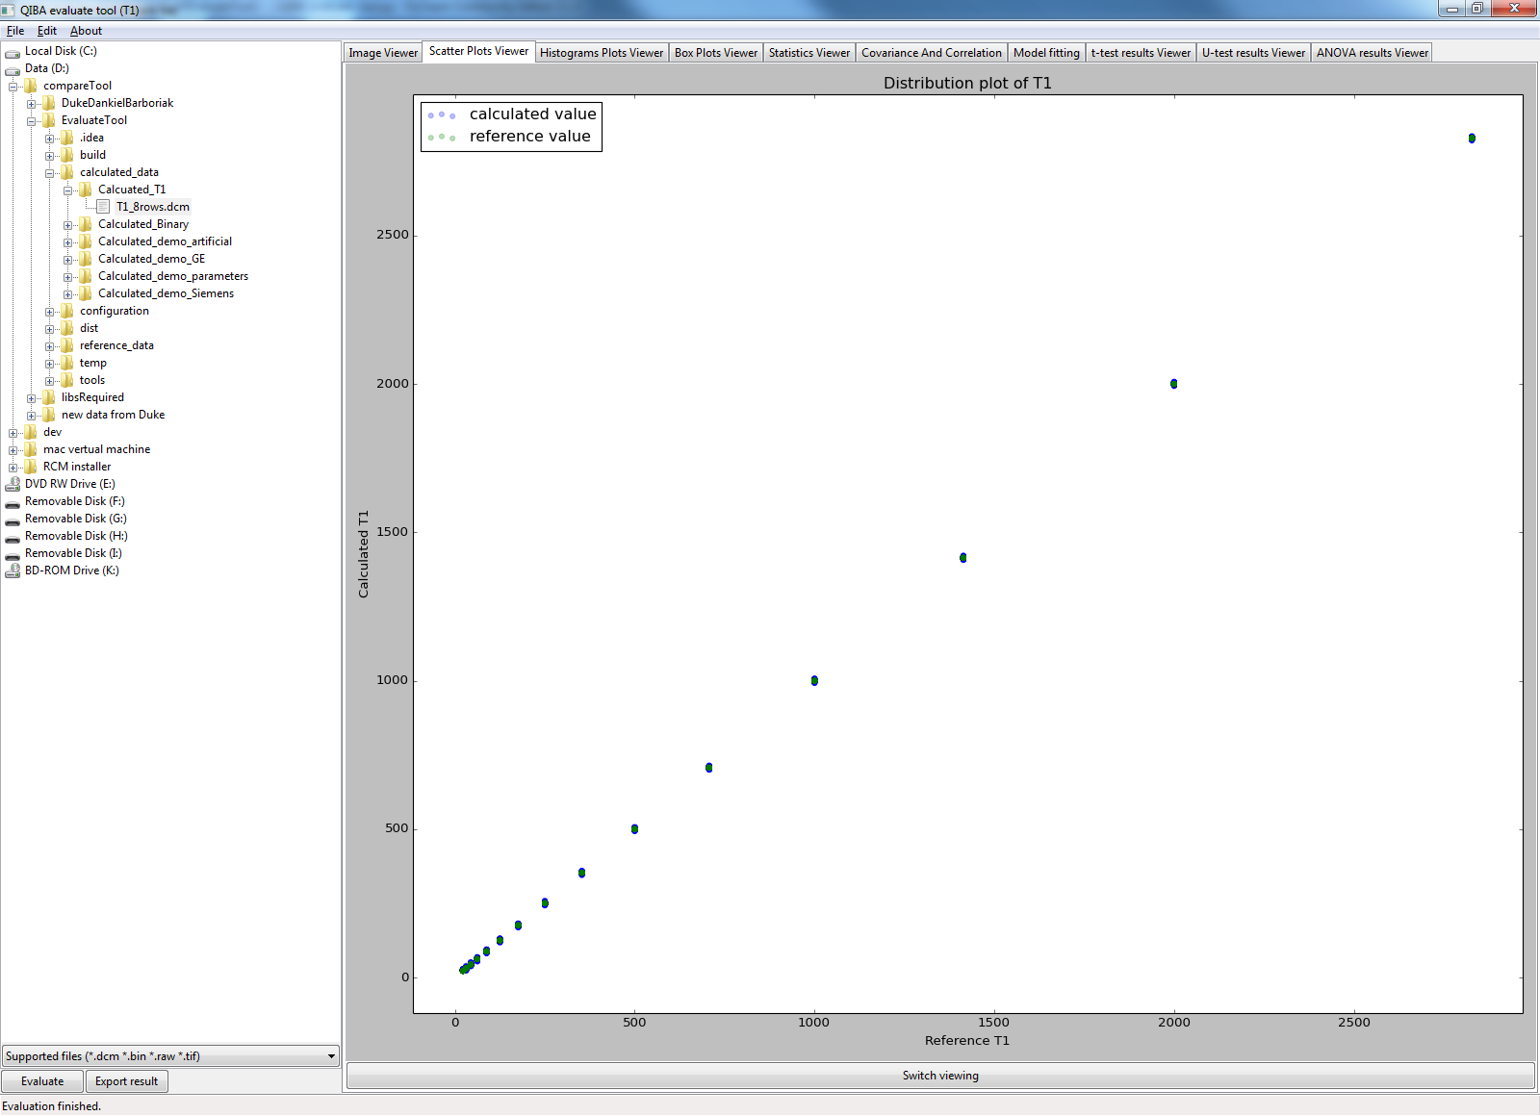

Figure 12: Scatter plots for "Flip Angle T1"-mode

## Viewing the data distribution

The tab “Histograms Plots Viewer” shows the histogram of each patch from calculated Ktrans and Ve or T1, depending on which analysis mode you entered, so that you can have a look at the distribution of the pixels in each patch, with regards to difference parameter combination.

All histograms have the uniformed y-axis limits, so that the comparison among different patched is easier. The minimum and maximum values of a patch are denoted on the x-axis for reference. The parameters on the top-most and left-most are abstracted from the reference data. (When the dimension of the image is too large, the histograms may overlap. This shall be fixed in the future.)

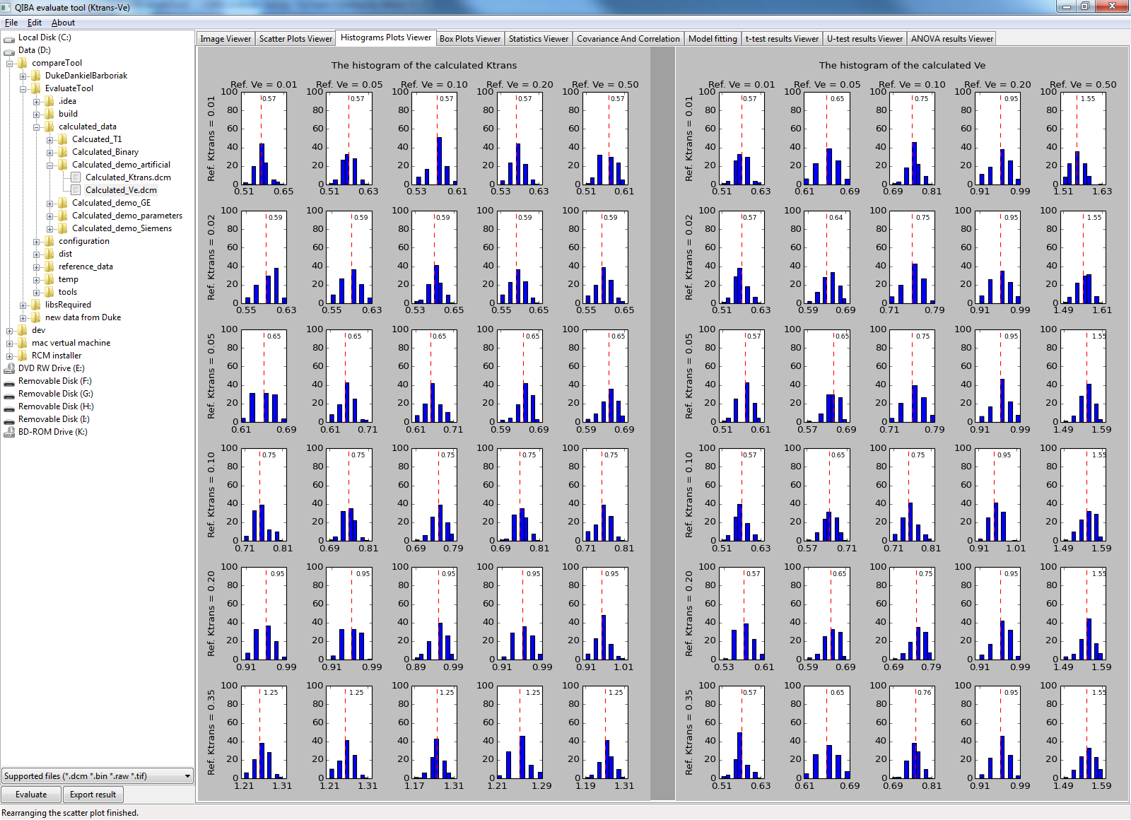

Figure 13: Histograms for "GKM"-mode

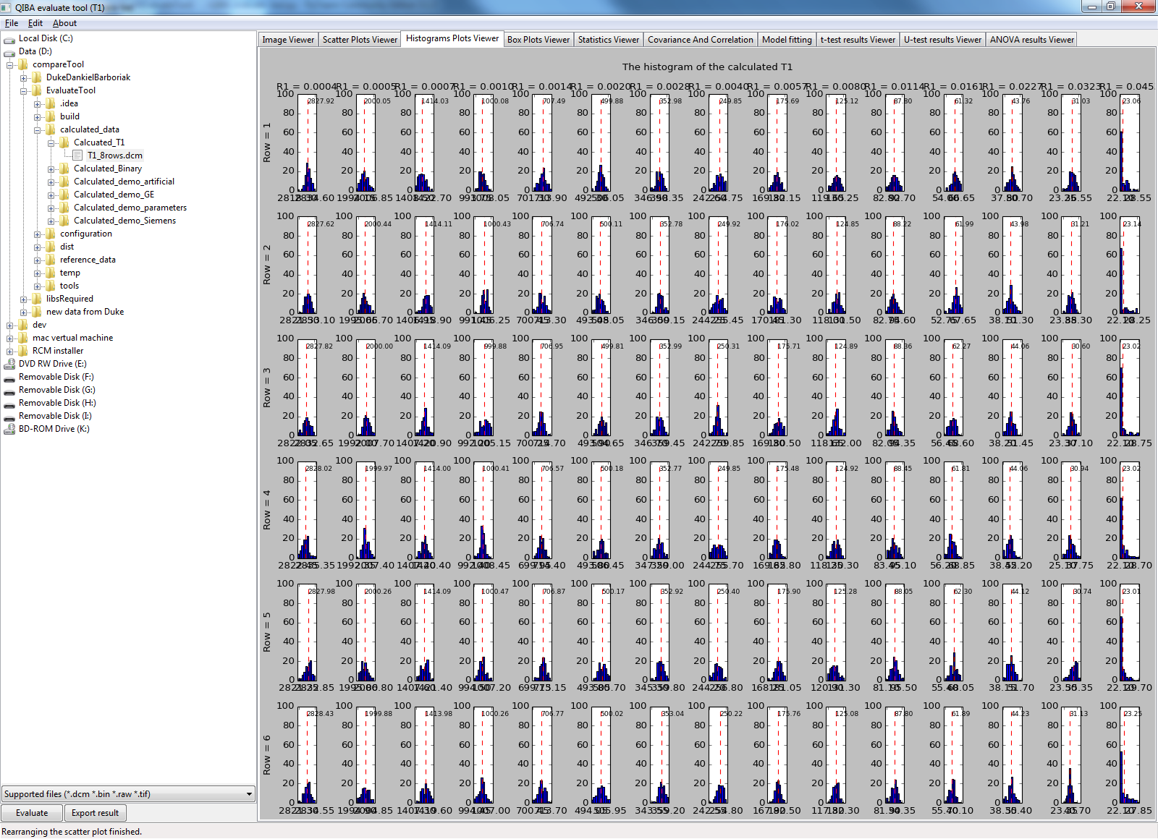

Figure 14: Histograms for "Flip Angle T1"-mode

The tab “Box Plots Viewer” shows the box plots of each patch in the calculated Ktrans and Ve or T1, depending on which analysis mode you entered. It offers another view of the distribution of the patches with different parameter combinations.

The vertical dash lines are used to separate the rows (or columns), as each box plot is responsible for one patch. From these plots you could get some statistics information of each patch, like the mean value, the 1st and 3rd quartile, the minimum and maximum value. The more precise value of those statistics could be found in the tab “Result in HTML viewer”.

Note: for the T1 analysis mode, the plots shows the values as R1, which are calculated as R1 = 1/T1.

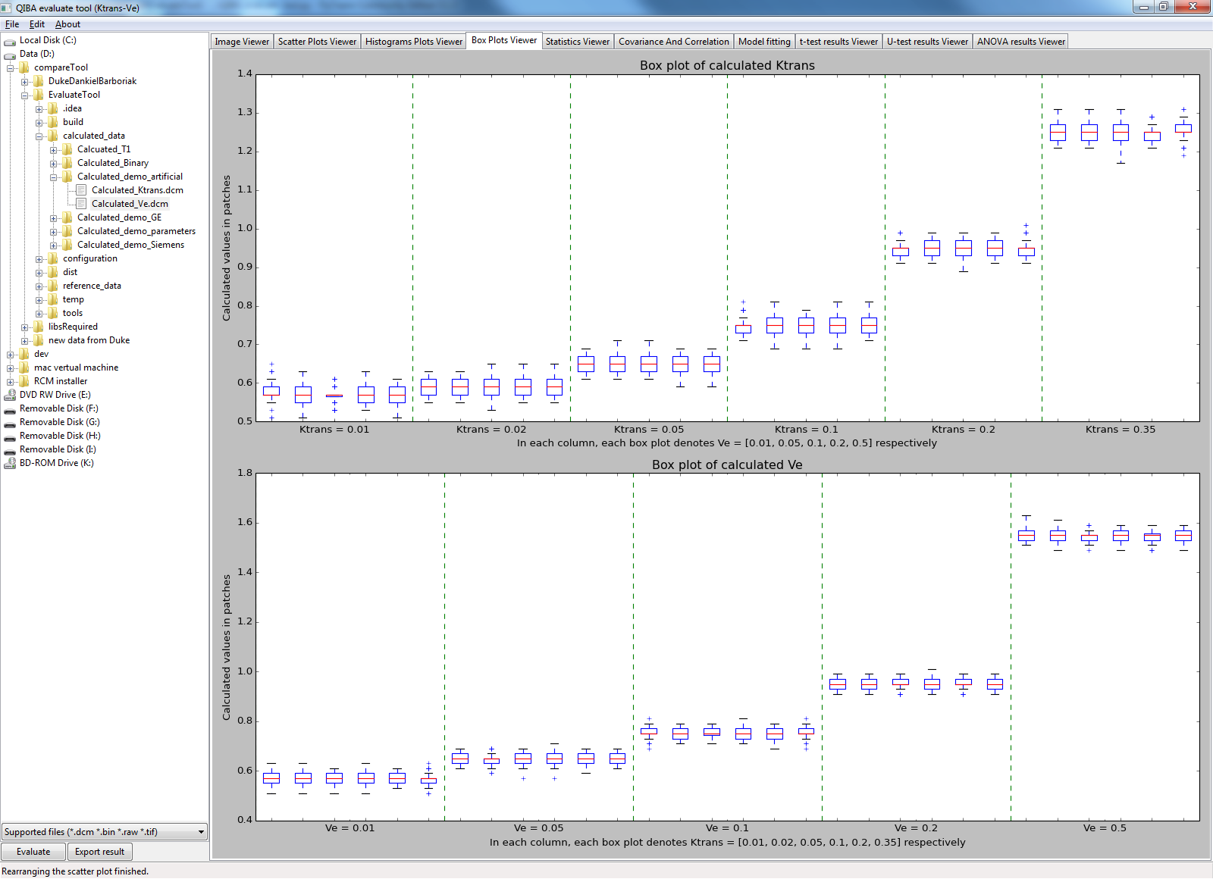

Figure 15: Box plots for "GKM"-mode

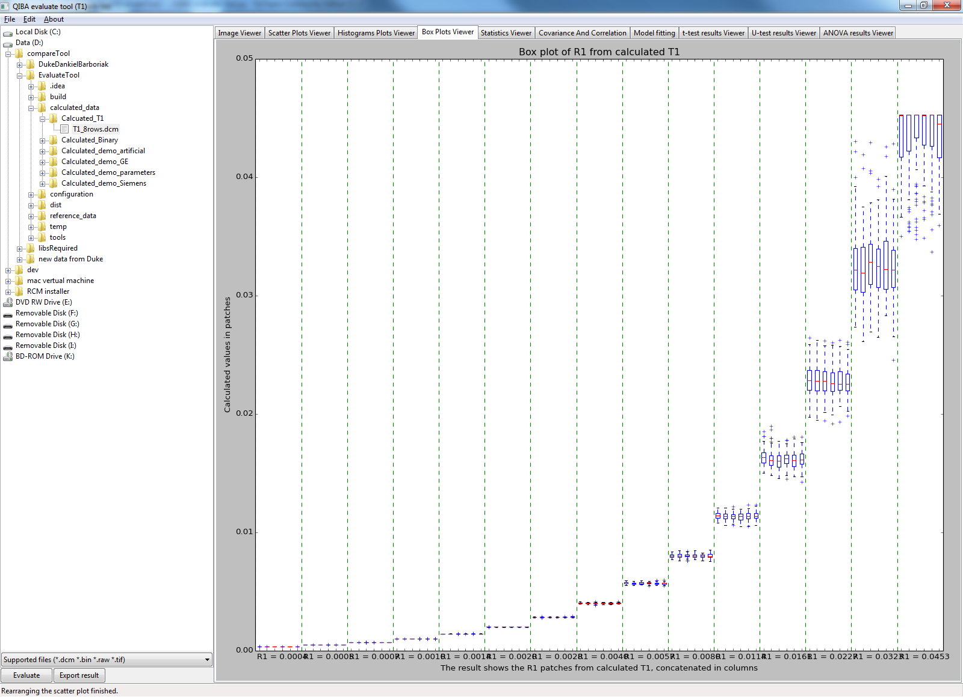

Figure 16: Box plots for "Flip Angle T1"-mode

## Statistics tables

The tab “Statistics Viewer” shows the statistics in HTML form. Unlike the tabs introduced before, this tab shows the results without data visualization method. From these tables you can read the value more precisely.

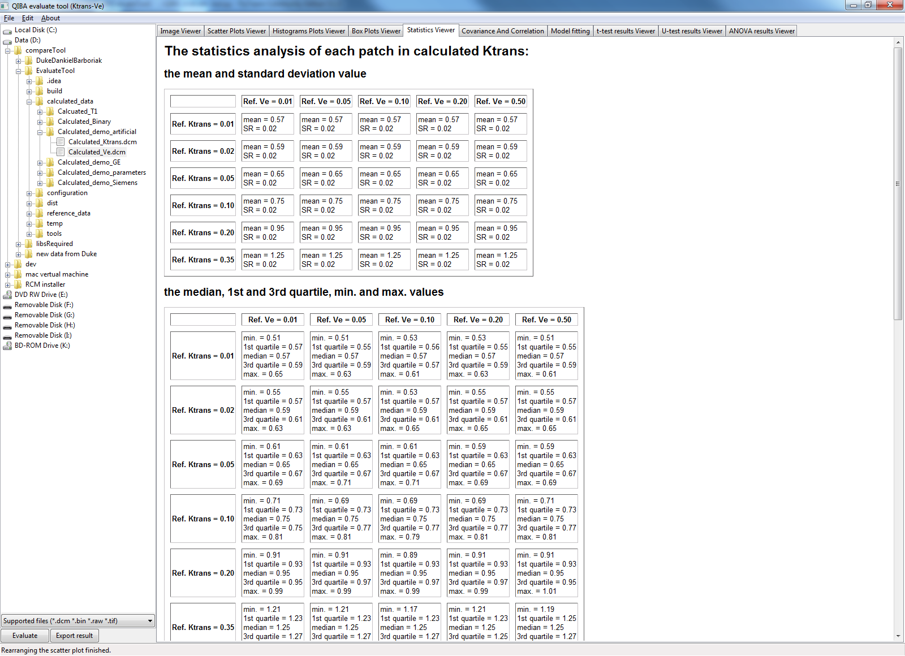

Figure 17: Statistics tables for "GKM"-mode

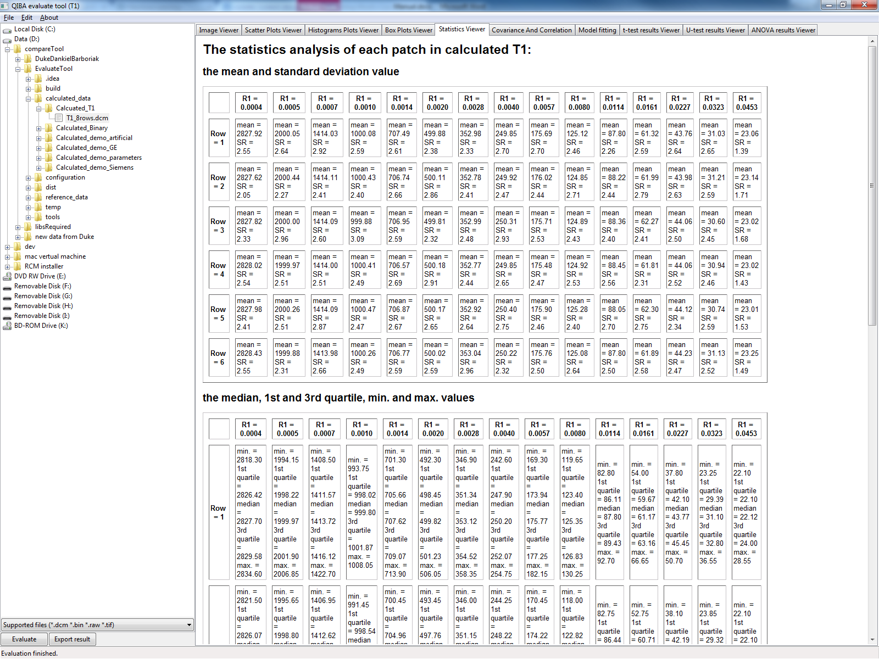

Figure 18: Statistics tables for "Flip Angle T1"-mode

## Covariance and correlation

The tab “covariance and correlation” shows the covariance/correlation between each column/row of calculated Ktrans/Ve and reference Ktrans/Ve. For T1 analysis mode, the results show the correlation/ covariance between each row of calculated and reference T1 map. The results are shown in tables respectively. From this tab, you could see the relation between the calculated values and the reference values.

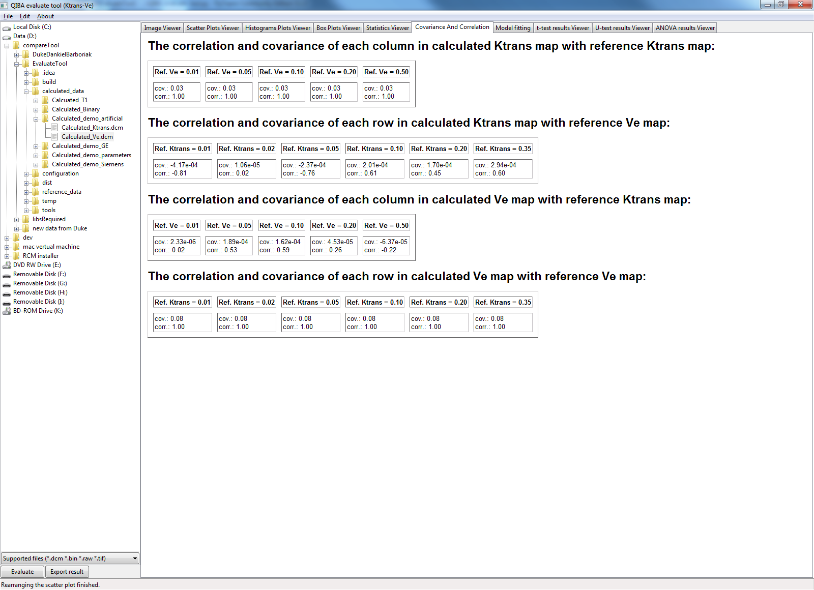

Figure 19: Covariance/correlation tables for "GKM"-mode

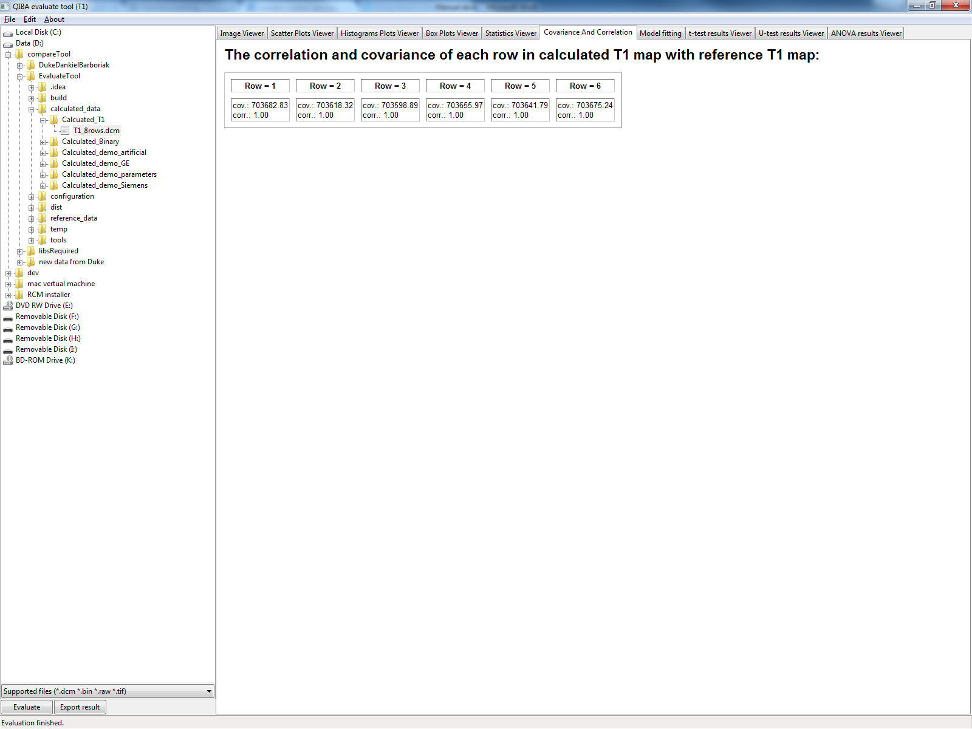

Figure 20: Covariance/correlation tables for "Flip Angle T1"-mode

## Concordance correlation coefficients

The tab “concordance correlation coefficients” shows the calculated results of concordance correlation coefficients between each patch of the calculated and reference data.

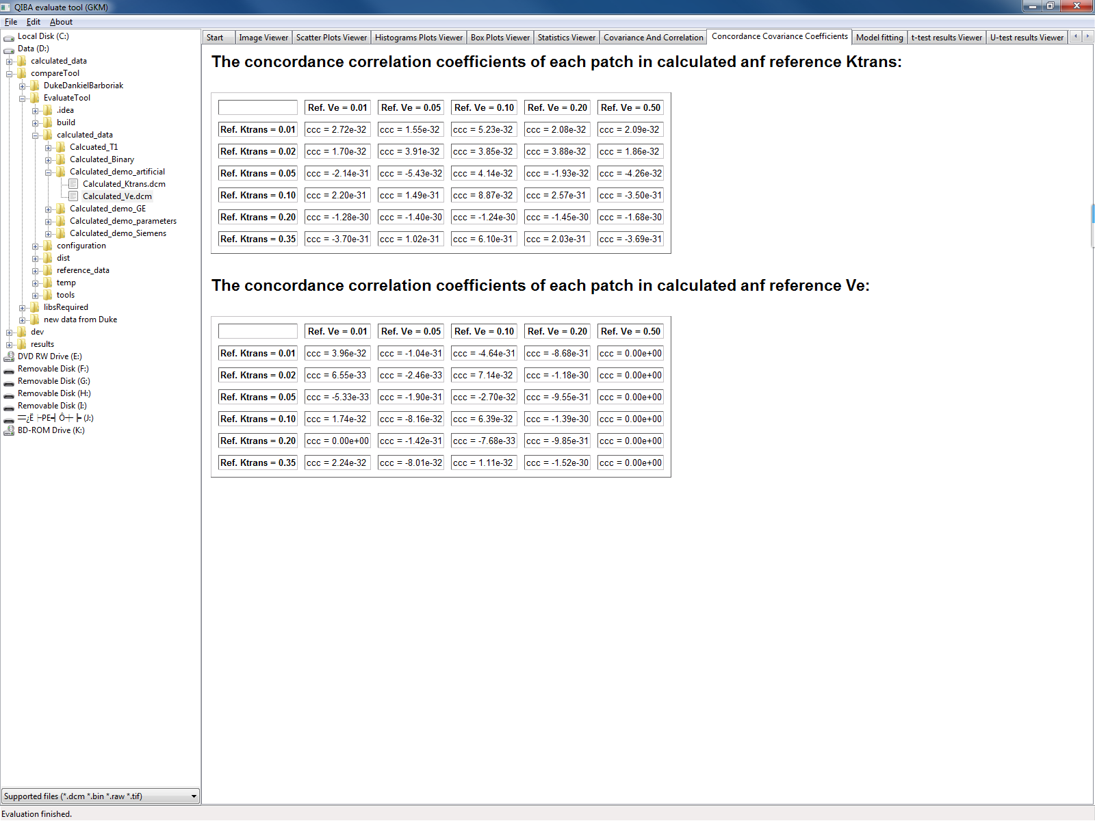

Figure 21: Concordance correlation coefficients tables for "GKM"-mode

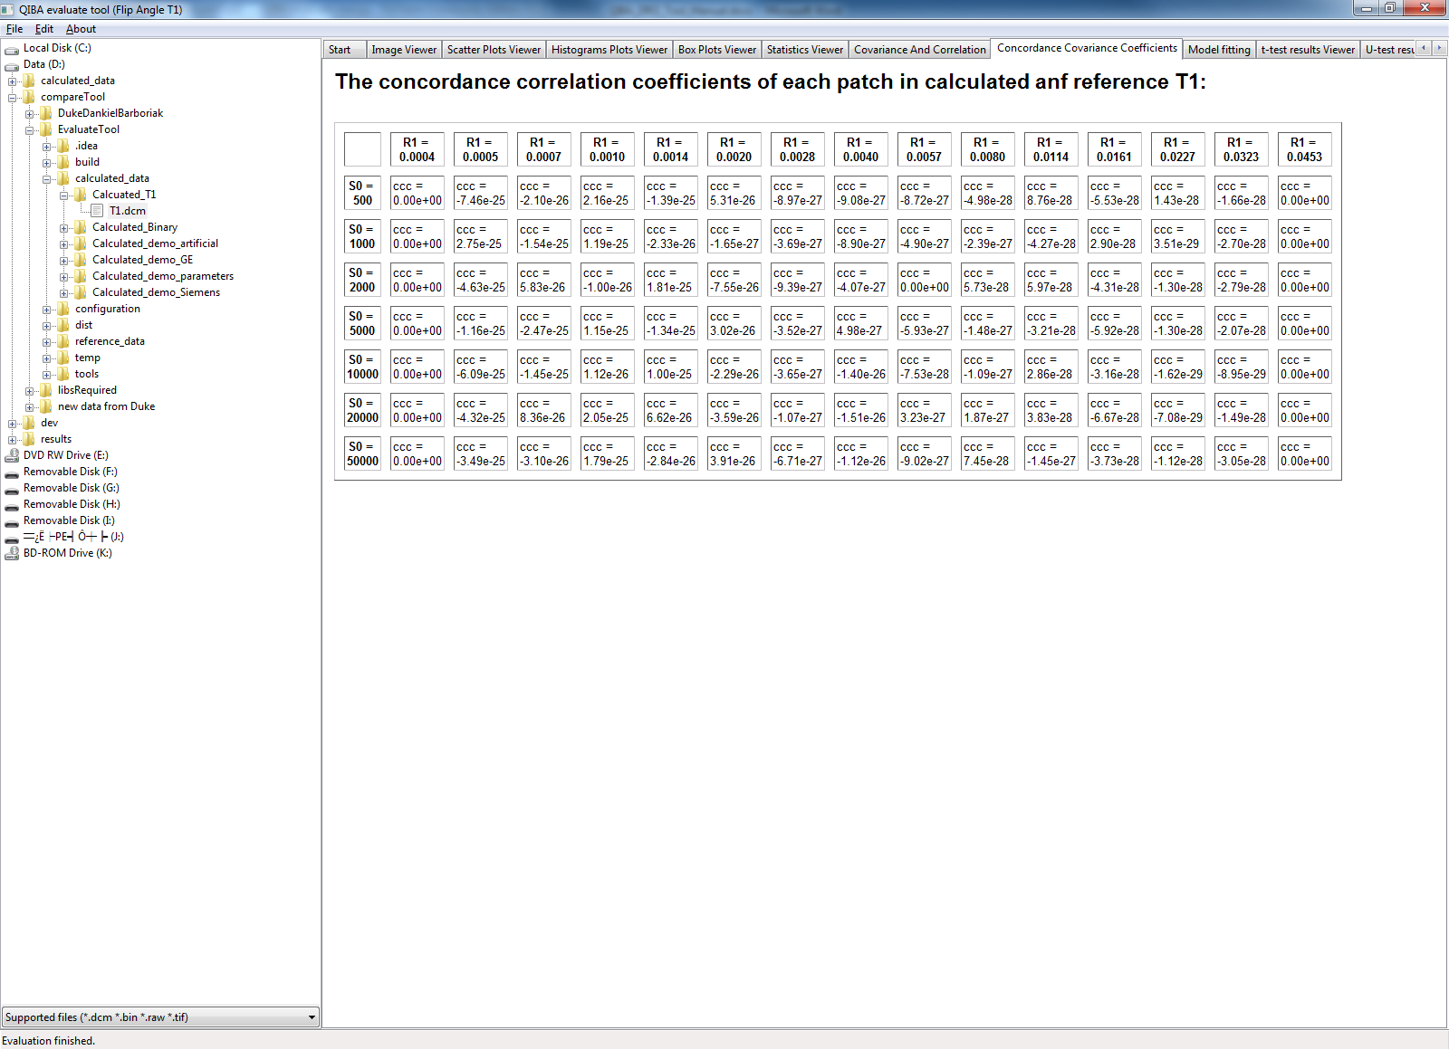

Figure 22: Concordance correlation coefficients tables for "Flip angle T1"-mode

## Model fitting

The tab “Model Fitting” shows the result of fitting linear model and logarithmic model. The calculation is done between the calculated and reference data fitting the linear and logarithmic models. The data used to fit the model are mean value of each patch.

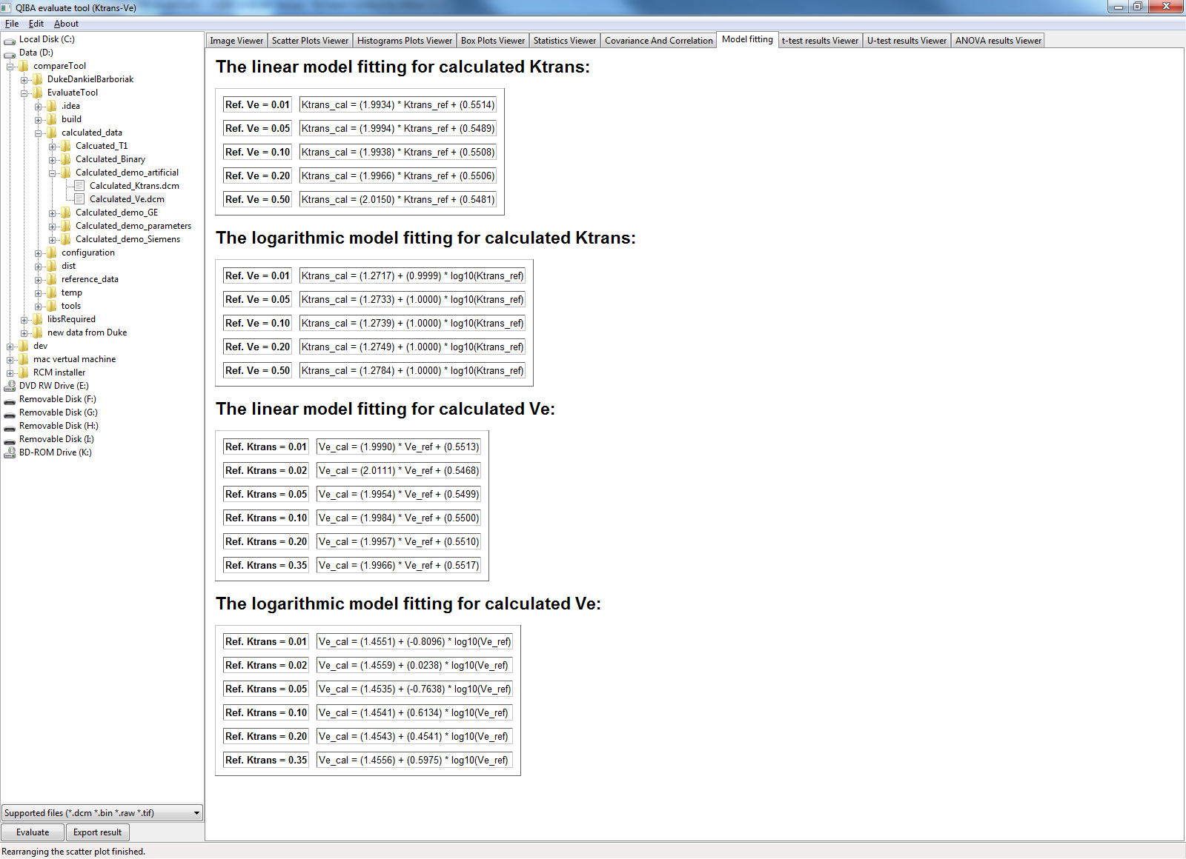

Figure 23: Model fitting results for "GKM"-mode

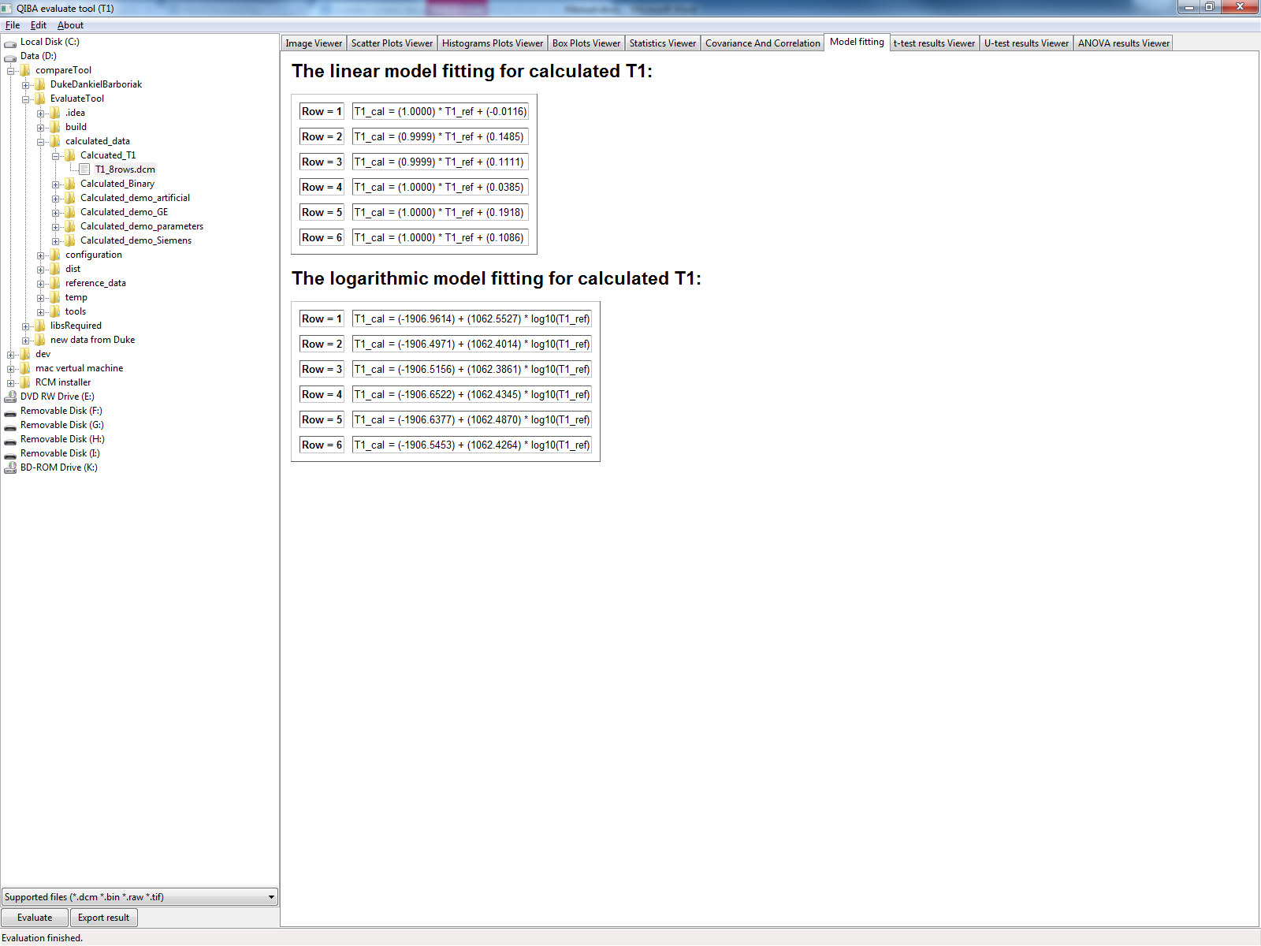

Figure 24: Model fitting for "Flip Angle T1"-mode

## T-test results

The tab “t-test results Viewer” shows the results of t-test on each patch in calculated Ktrans and Ve or T1, depending on which analysis mode you entered. T-test gives a reference of how far are the group of calculated values in each patch from the reference values. The tests are done between the calculated patch and the reference value.

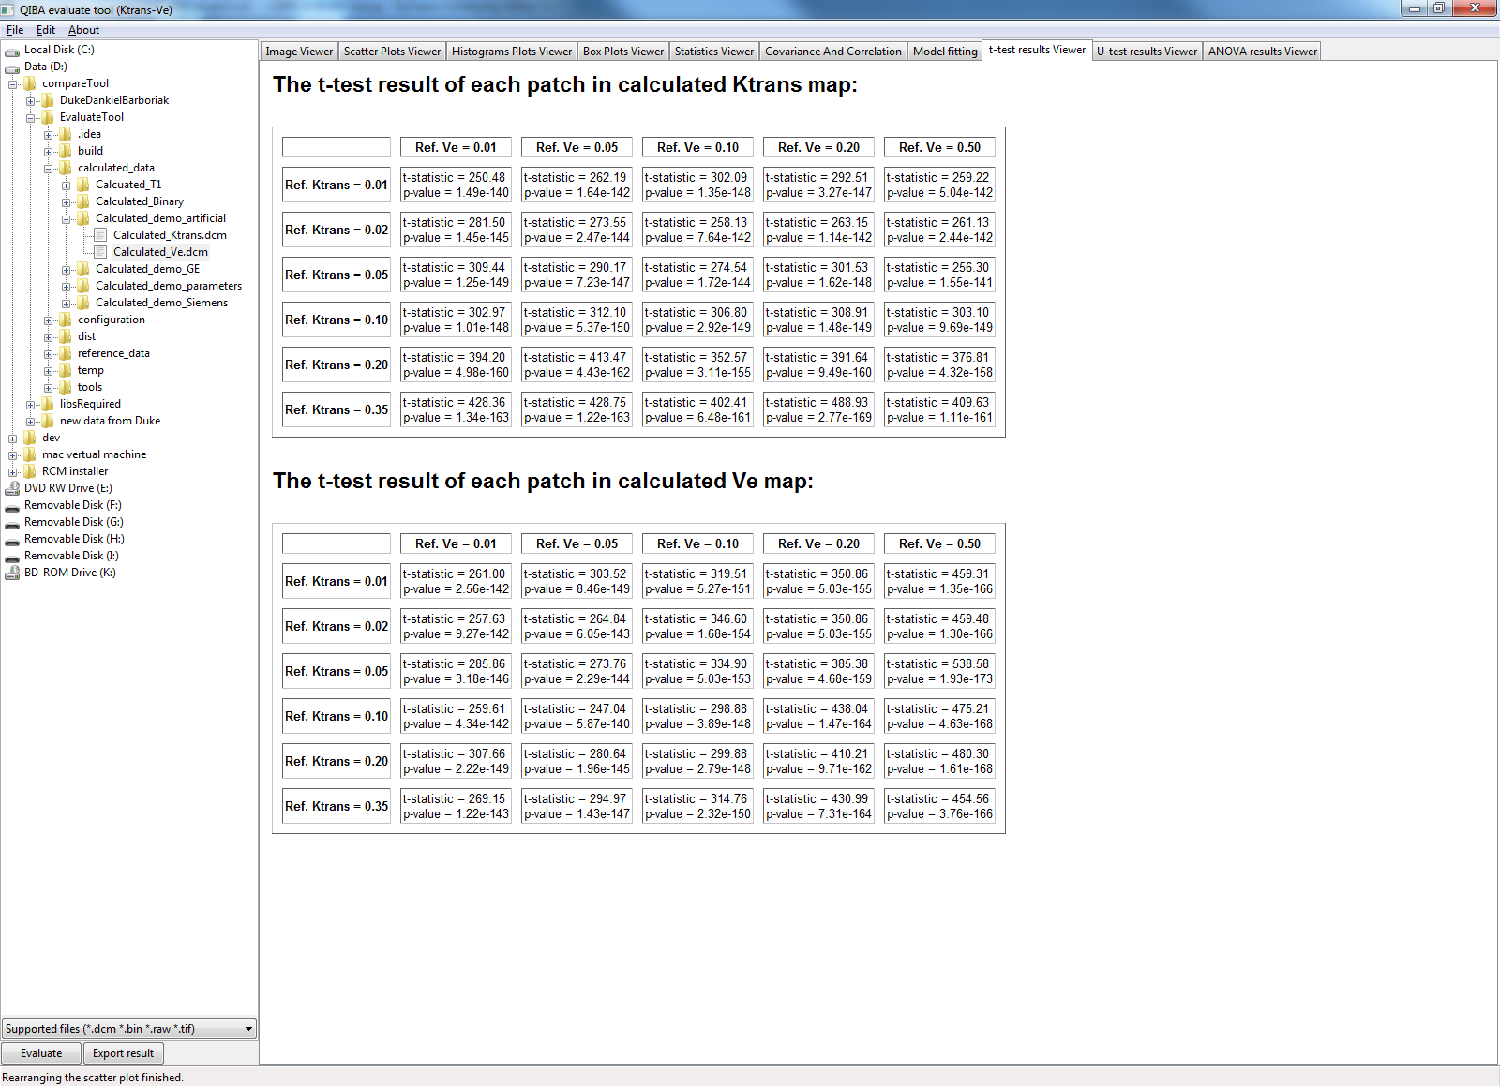

Figure 25: T-test results for "GKM"-mode

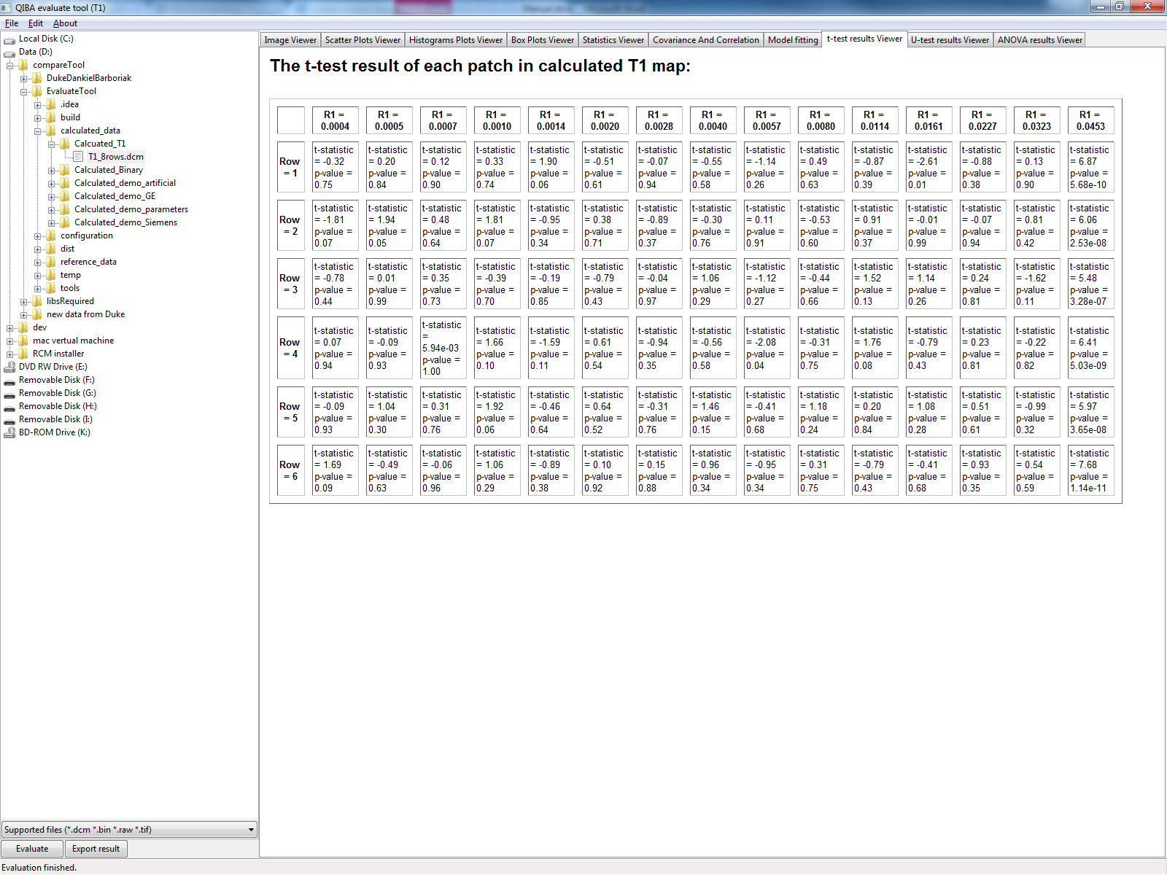

Figure 26: T-test results for "GKM"-mode

## U-test results

The tab “U-test results viewer” shows the results of Mann-Whitney U-test of each patch against the reference patch. Mann-Whitney U-test offers a reference that whether two groups of data are the same or not. The tests are done between calculated patch and the corresponding reference patch.

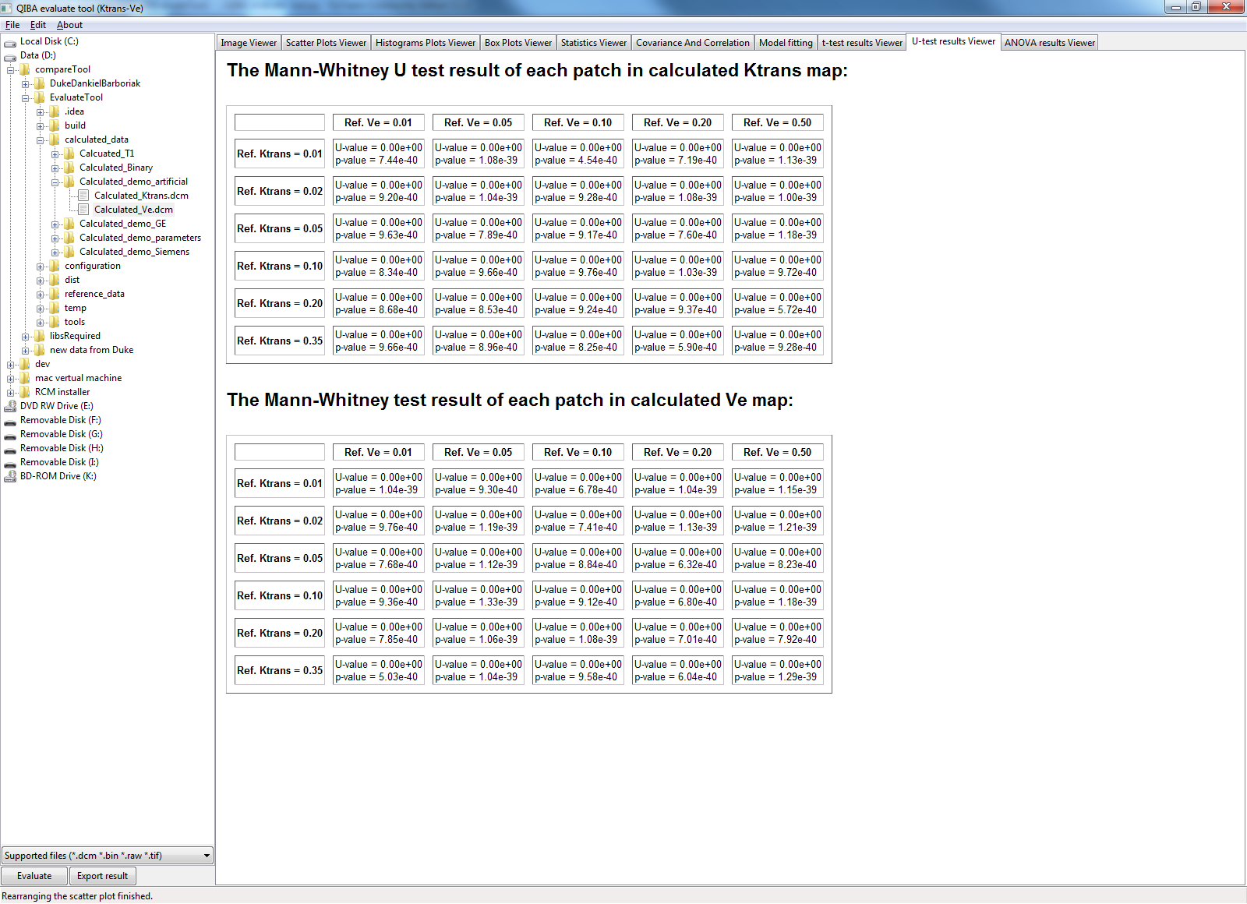

Figure 27: U-test results for "GKM"-mode

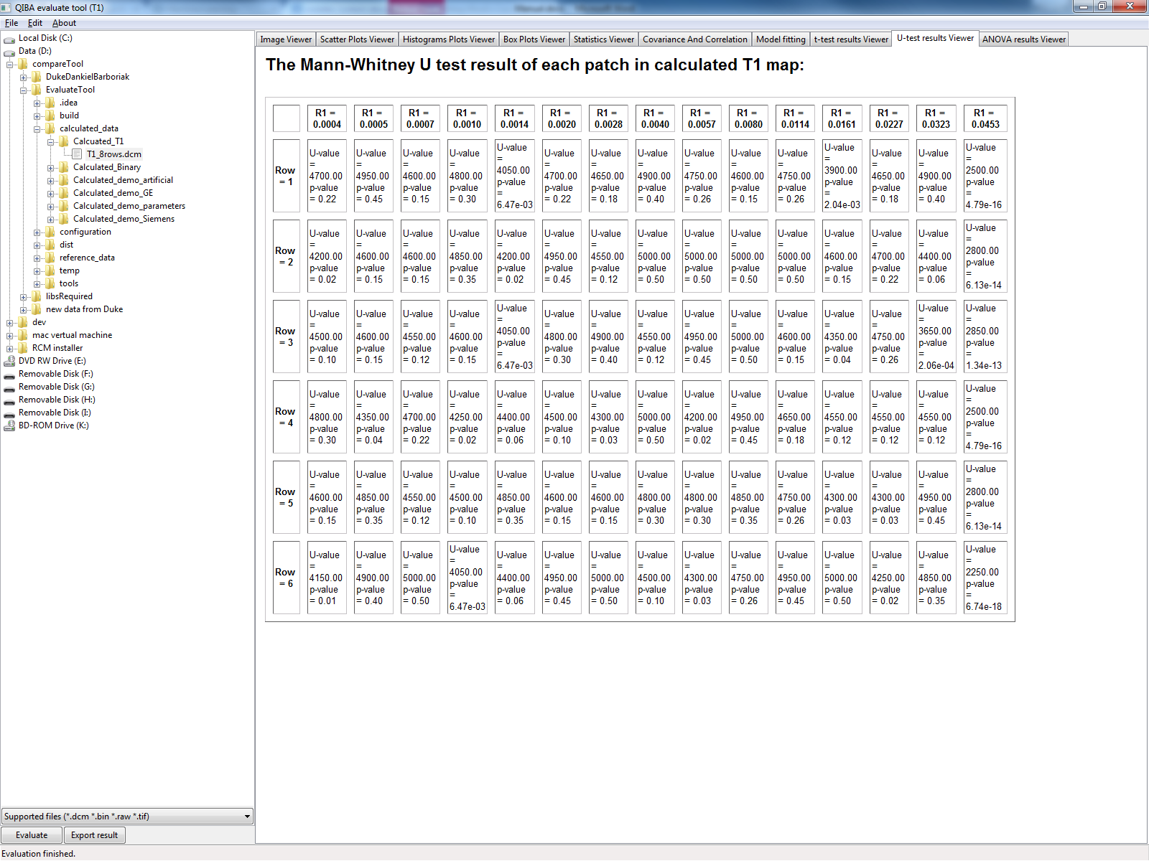

Figure 28: U-test results for "Flip Angle T1"-mode

## ANOVA results

The tab “ANOVA results viewer” shows the results of ANOVA of each row/column of calculated Ktrans/Ve or T1 against the reference values, depending on which analysis mode you entered. The calculations are done with patches of the maps.

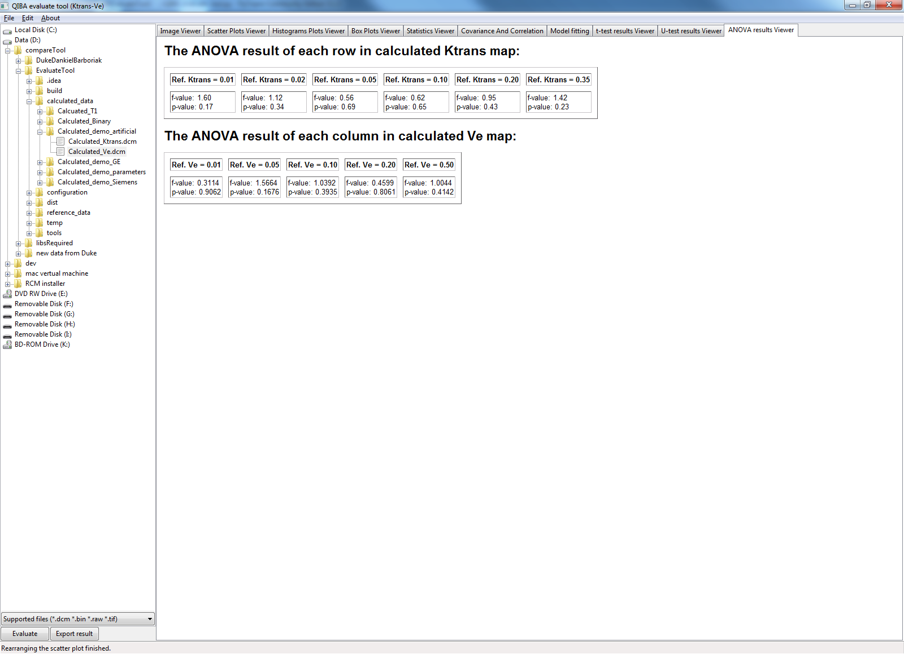

Figure 29: ANOVA results for "GKM"-mode

## Chi-squared test results

The tab “Chi-squared test results” shows the Chi-squared test results of each patch of the calculated data.

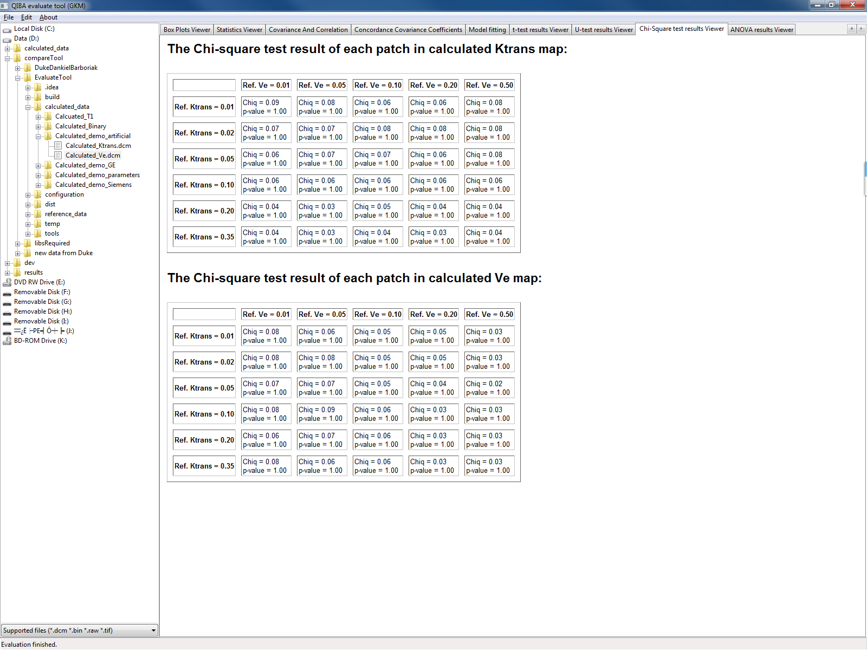

Figure 30: Chi-square test results for "GKM"-mode

# Export the results as PDF

The evaluation results could be exported either in PDF or as PNG and Excel file, for further reference. The file will be organized in the order of the tabs, i.e. the content of each tab will be concatenated to form the results PDF or the Excel file. In order to export the results, you can simply click on the option from the menu: “File -> Export the results…” after the evaluation (see Figure 30).

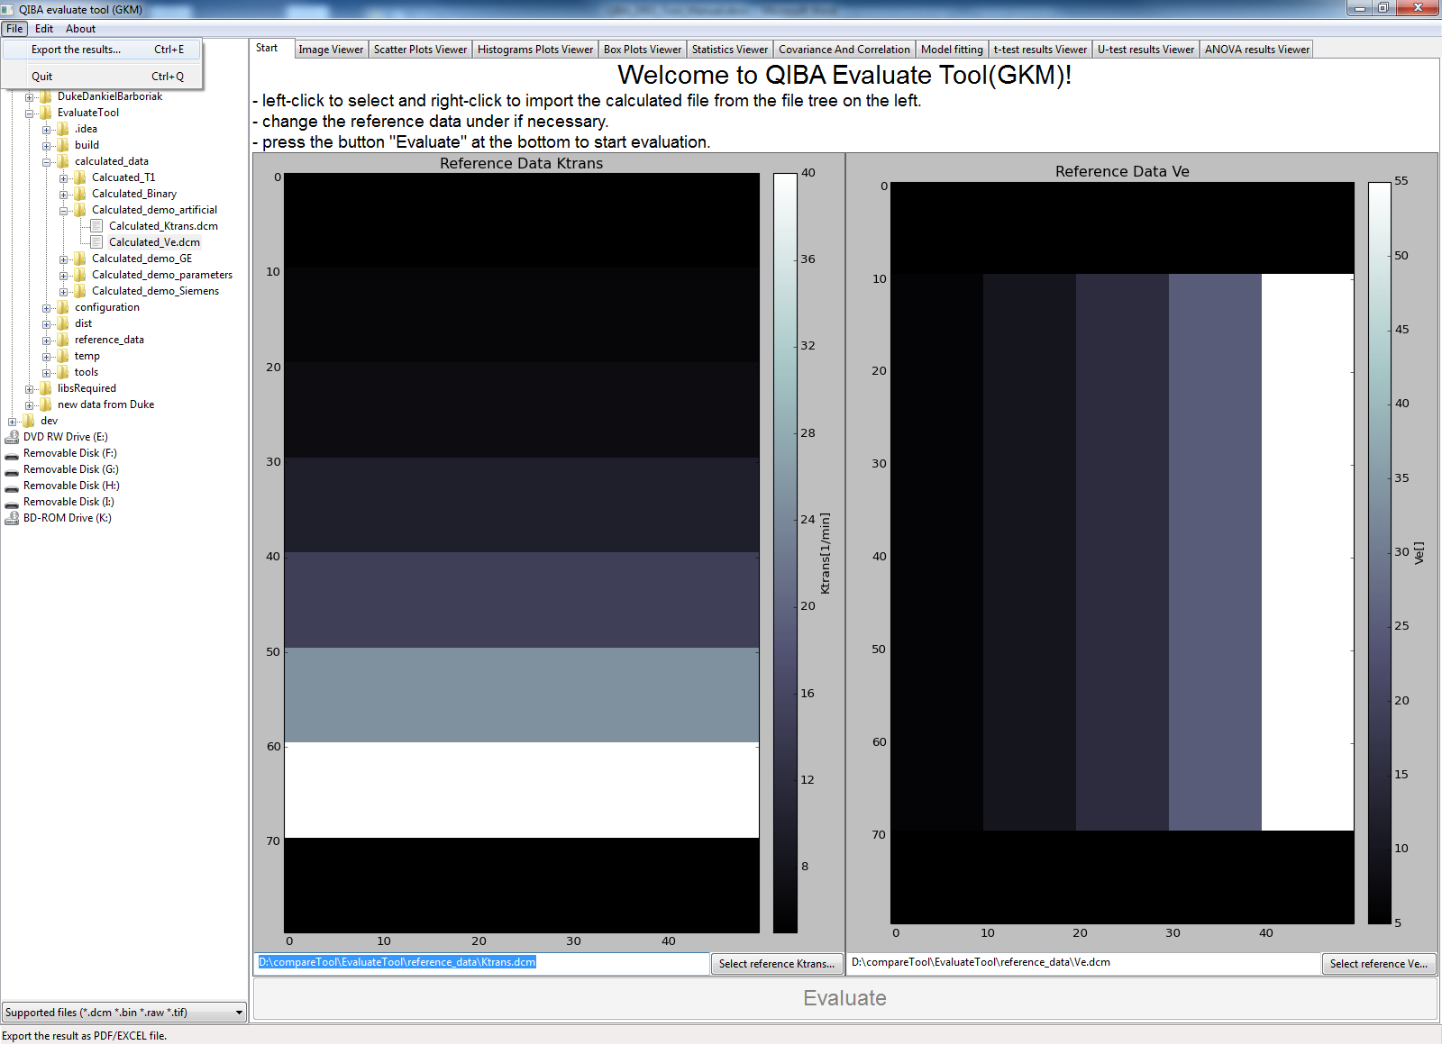

Figure 31: Export results option

In the popup dialog, you may choose the file type you want to export as.

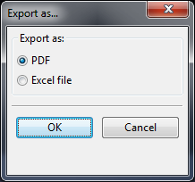

Figure 32: Export option dialog

If it was chosen to export the results as PDF, a save file dialog will pop out to let you choose the file name and location to save (see Figure 31).

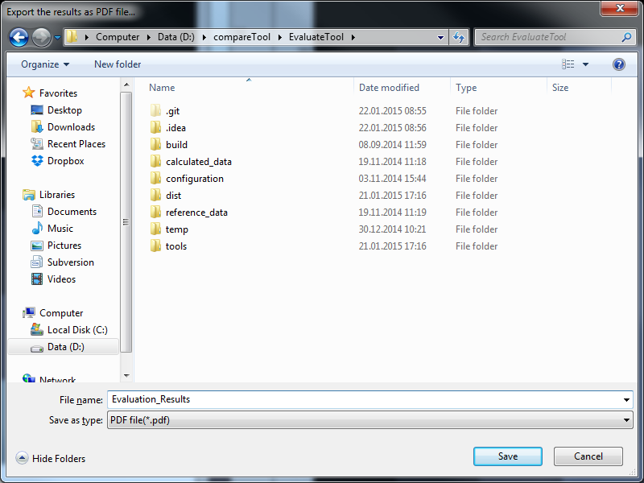

Figure 33: Save file dialog

When “Save” is pressed in this dialog, a console will pop out, and disappear automatically when the exporting was finished (see Figure 32). Then you can find the saved PDF at the chosen location.

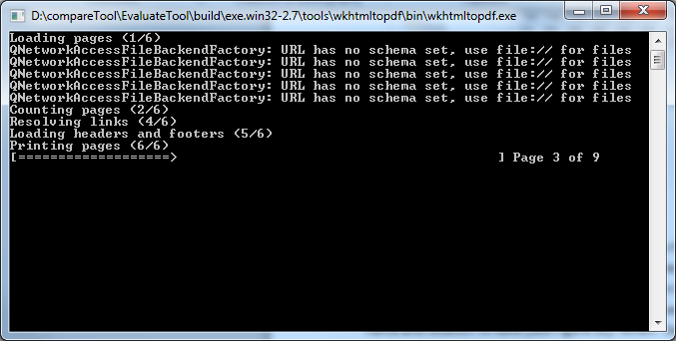

Figure 34: Exporting console

In case it is chosen that the results to be exported as excel, a directory selection dialog will popup, in which you could choose the destination directory to export the results, under which the figures and an Excel file will be saved.

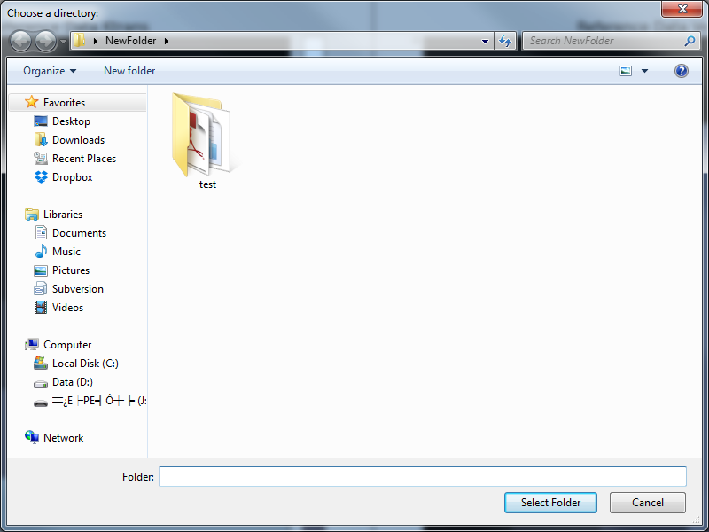

Figure 35: Destination directory selection dialog

# Appendix I

## How to download the source code

The source code is available online at <https://bitbucket.org/hlaue/qiba-pdf-evaluation-tool>. (The repository is currently only accessible to the developers.)

By clicking on the “Download” button on the left side of the page, you can download a copy of the repository. The main source codes of this project are “[QIBA_evaluate_tool.py](https://bitbucket.org/hlaue/qiba-pdf-evaluation-tool/src/242ee8d9a14c748cbe6fd415270721266635a47b/QIBA_evaluate_tool.py?at=master)”, “[QIBA_fucntions.py](https://bitbucket.org/hlaue/qiba-pdf-evaluation-tool/src/242ee8d9a14c748cbe6fd415270721266635a47b/QIBA_evaluate_tool.py?at=master)” and “QIBA_models.py”.

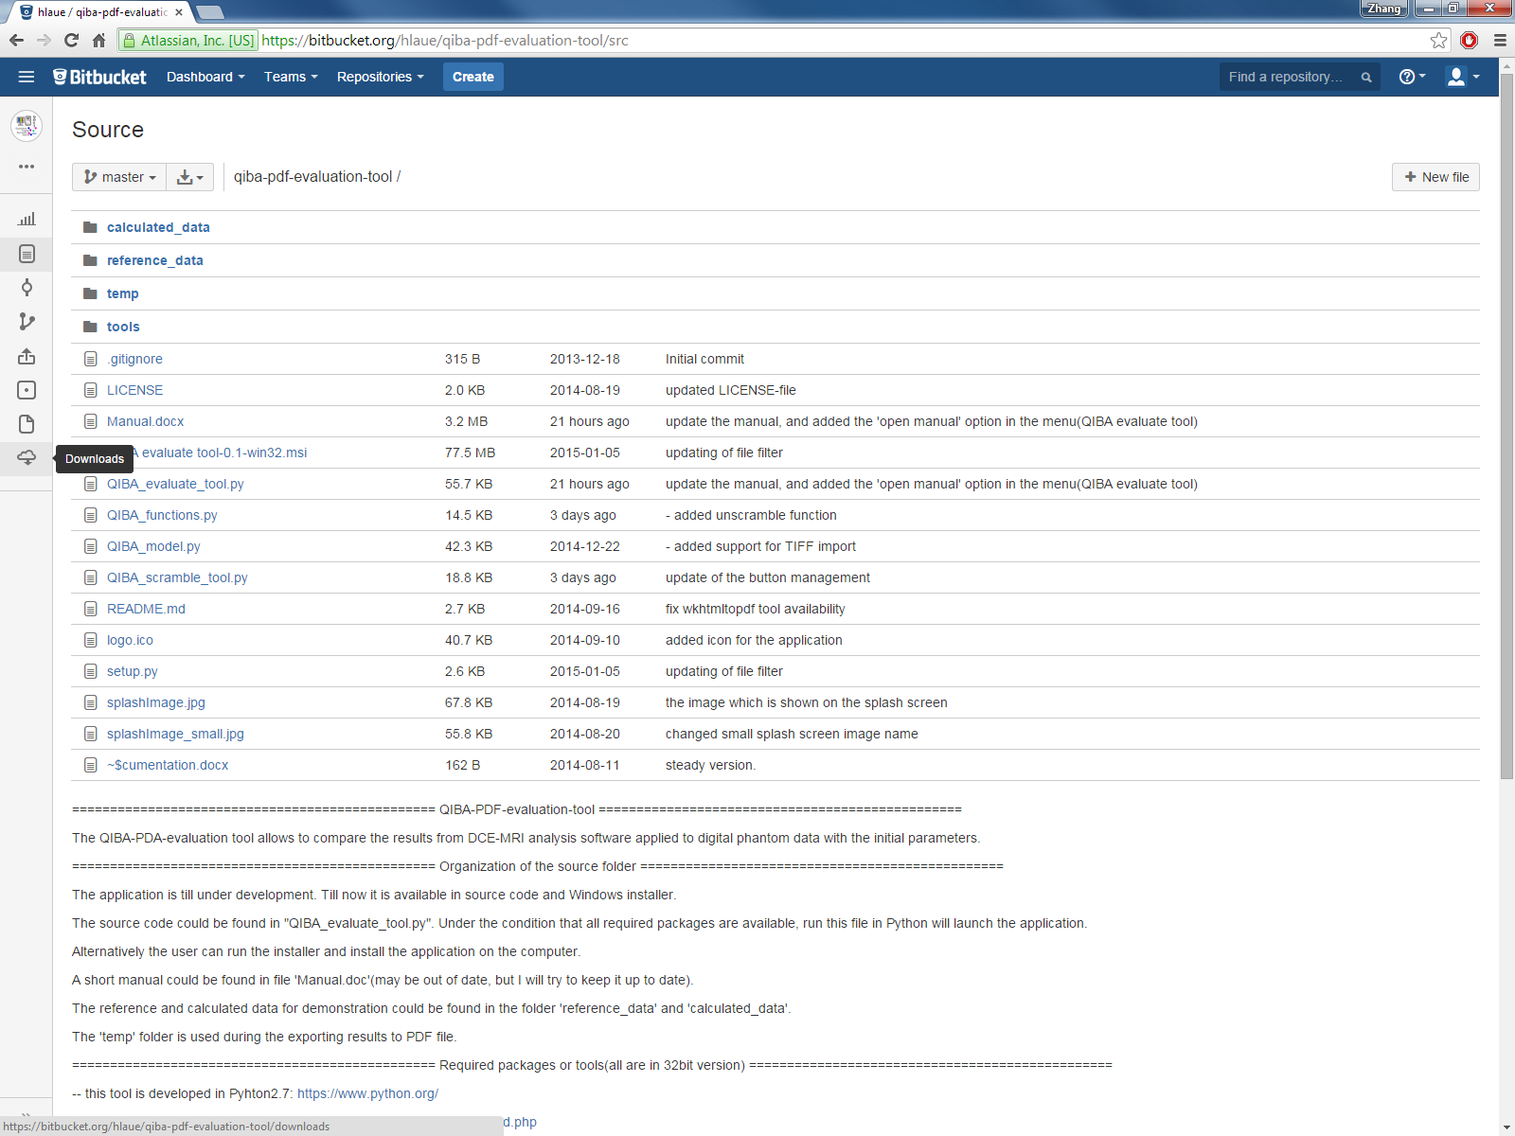

Figure 36: Source code page in Bitbucket

## How to run the source code

Before running the source code, we strongly recommend you to check the file “README.md”. The necessary packages for running the source code are listed there. Make sure you have all the required packages installed on the computer of the correct version.

To launch the application with source code, simply open the Windows console, and type “python QIBA_evaluate_tool.py -option”. The difference is whether application opens with the corresponding analysis mode directly, or pops out a selection dialog after launching.

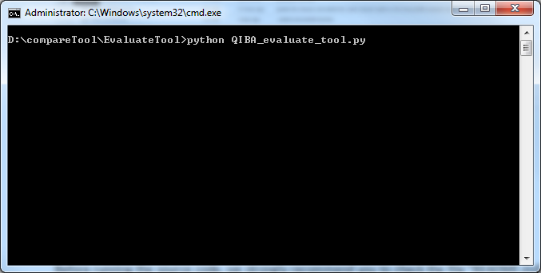

Figure 37: Open the application with source code

List of the option:

-b batch

The main window will not be shown, and the evaluation will be started and the results will be saved in the destination directory, which is given in the option –d

-m (either GKM or T1)

The analysis mode to be launched, either GKM or flip angle T1 mode.

-c (the path of the calculated files, should be given without empty space between paths and separated with “,”, e.g. D:\calculated_data\Ktrans,D:\calculated_data\Ve.dcm)

-r (optional, the path of the reference files, should be given without empty space between paths and separated with “,”, e.g. D:\reference_data\Ktrans,D:\reference_data\Ve.dcm)

-d (the destination directory for the evaluation results, e.g. D:\results)

## How to execute the application for batch processing

In case the user want to execute the application for batch processing, a recommended format of command is given as an example:

Python QIBA_evaluate_tool.py –b batch –m GKM –c D:\calculated_data\Ktrans,D:\calculated_data\Ve.dcm –r D:\reference_data\Ktrans,D:\reference_data\Ve.dcm –d D:\results

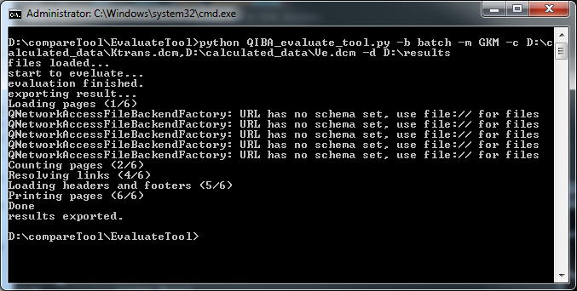

Figure 38: command line for batch processing